Standard Operating Procedure (SOP)
OP-10006 Feature to schedule data migration
Contents:
1. Purpose 1
2. Prerequisites 1
3. Detailed Procedure to Schedule Table Data Migration 1
3.1 Login to ScikIQ Platform 1
3.2 Navigate to Data Migration Feature 3
3.3 Select Source and Target Data sources 3
3.4 Select Tables for Migration 4
3.5 Analyze & Sync 5
3.6 POD Management 5
3.7 Review & Submit 6
3.8 Data Migration Request 7
3.9 Migration Schedule 8
3.10 Before Execution 9
3.11 During Execution 10
3.12 After Migration Completion 10

1. Purpose
This SOP outlines the step-by-step process to schedule and execute a Table Data Migration in the platform. It ensures consistent data transfer, proper scheduling, and automation while maintaining full control and traceability.

2. Prerequisites
• User must have valid access rights to the platform.
• Source and Target Data sources should already be configured.
• Tables to be migrated must be available and accessible.
• Verify that the Migration feature is enabled in the platform.

3. Detailed Procedure to Schedule Table Data Migration

3.1 Login to ScikIQ Platform
- Open the ScikIQ Platform login page in your browser.
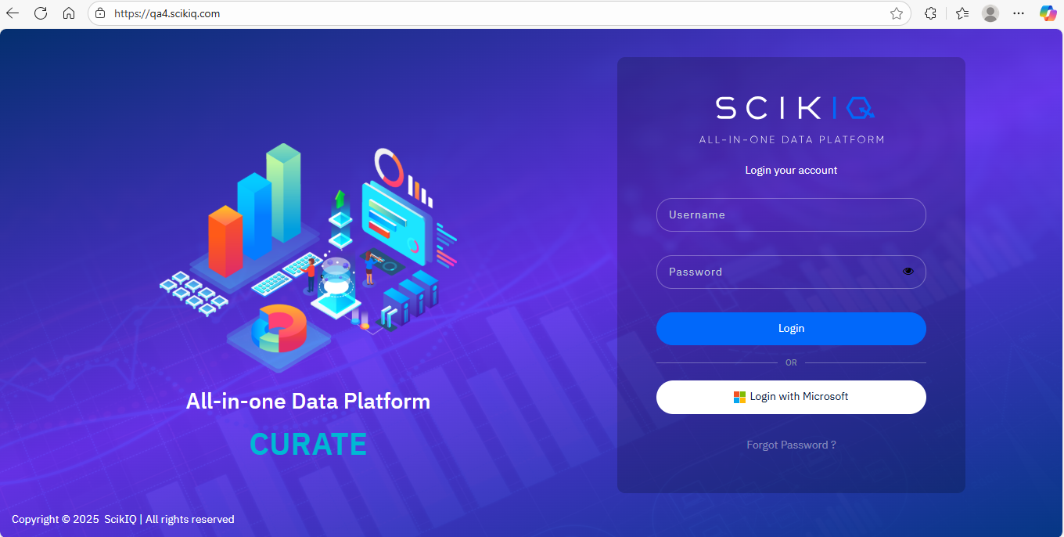
- Enter your username and password.
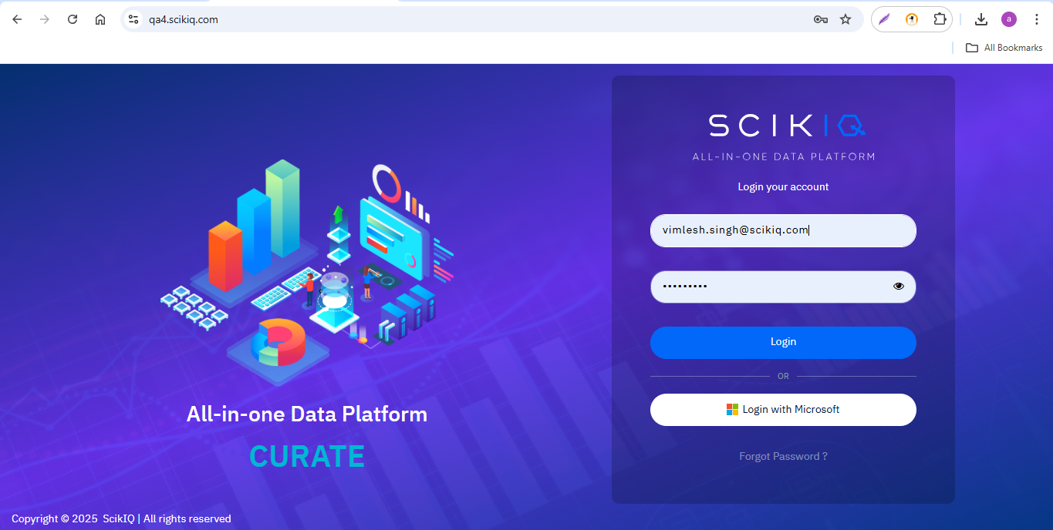
- Click Login to access the Home page.
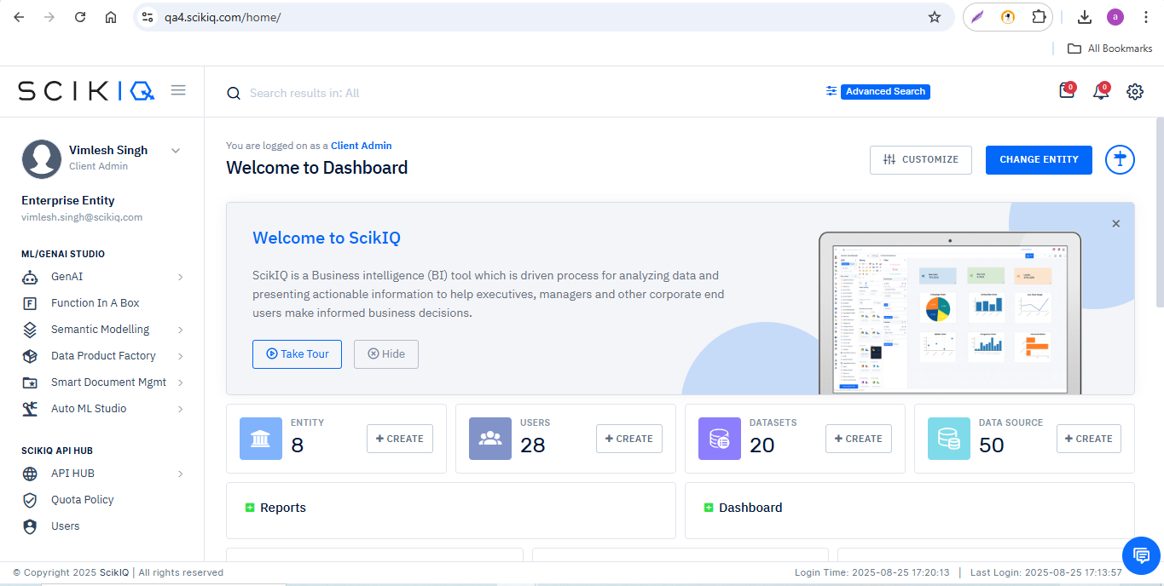

3.2 Navigate to Data Migration Feature
- From the left navigation menu, select Data Migration.
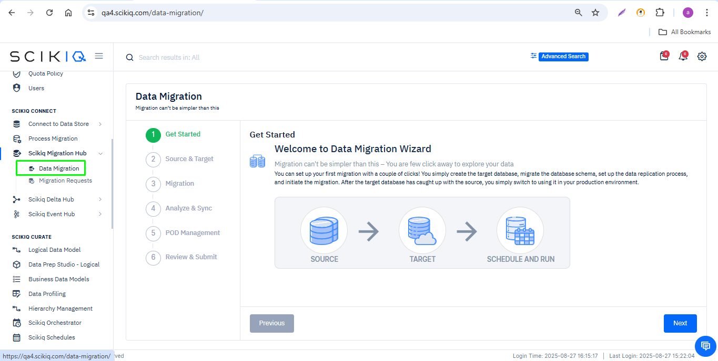

3.3 Select Source and Target Data sources
- In the configuration screen, choose the Source Data source.
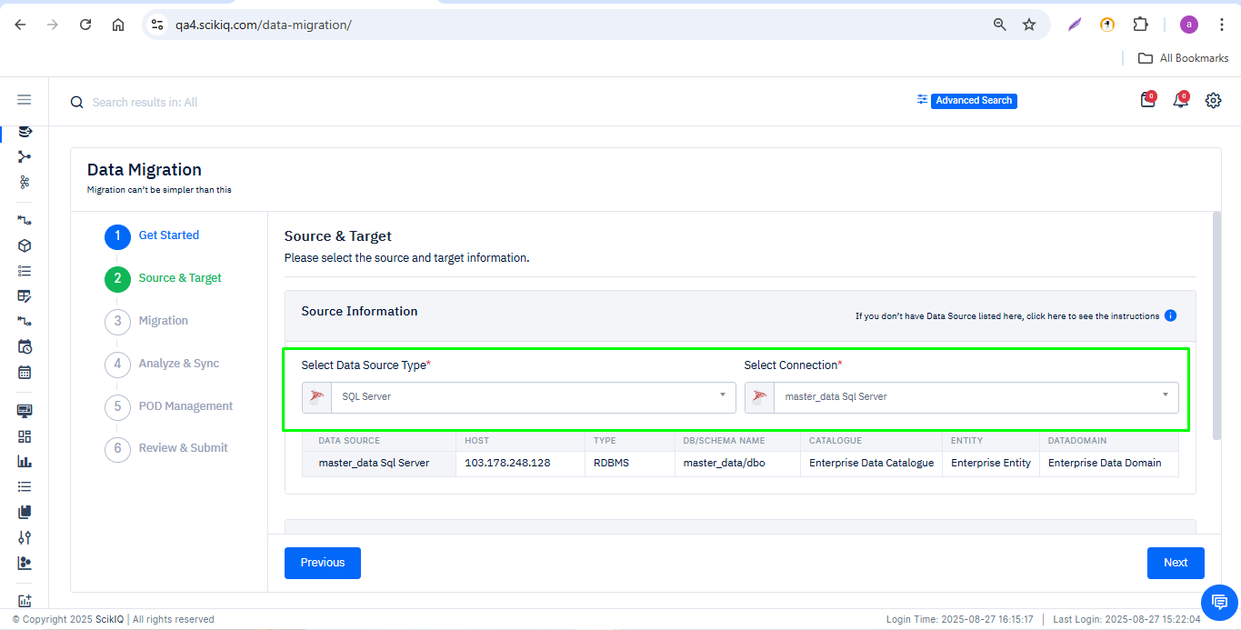
- Select the Target data source where the data will be migrated.
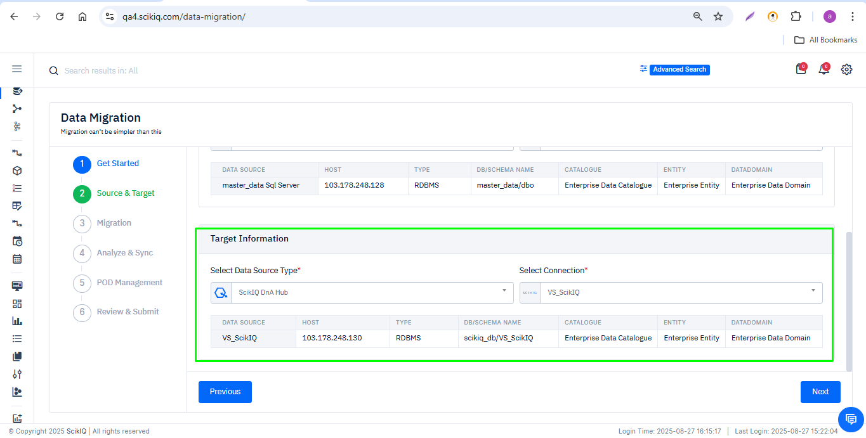

3.4 Select Tables for Migration
- Browse or search for the tables you wish to migrate.
- Select one or multiple tables as required.
- Click Next.

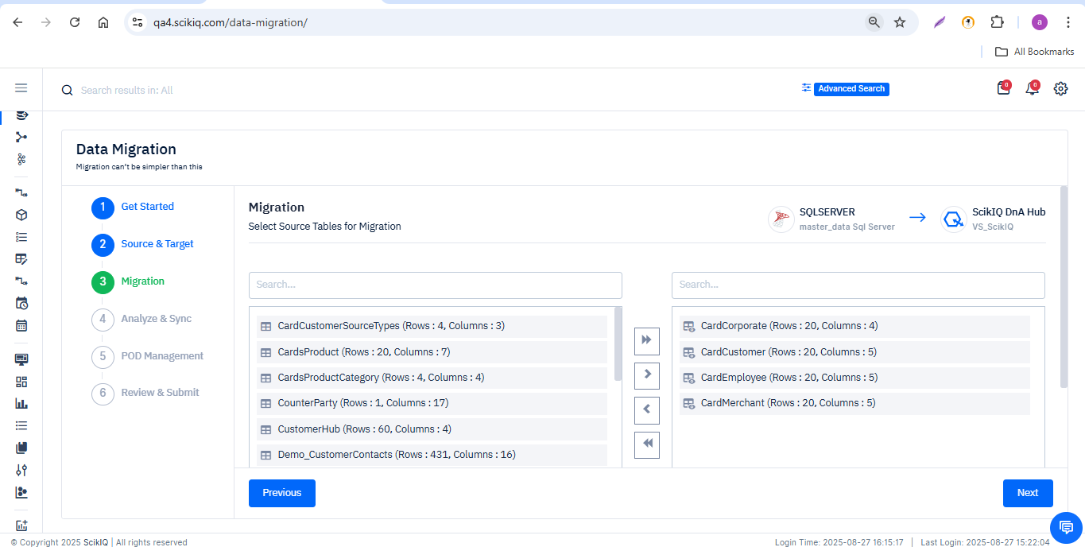

3.5 Analyze & Sync
- Review the table metadata, add new columns if required.
- Choose migration type: New Table or Existing Table.
- If New Table is selected, provide a new table name.
- Apply optional EDA (Exploratory Data Analysis), DQ (Data Quality), or edit metadata.
- Click Next.
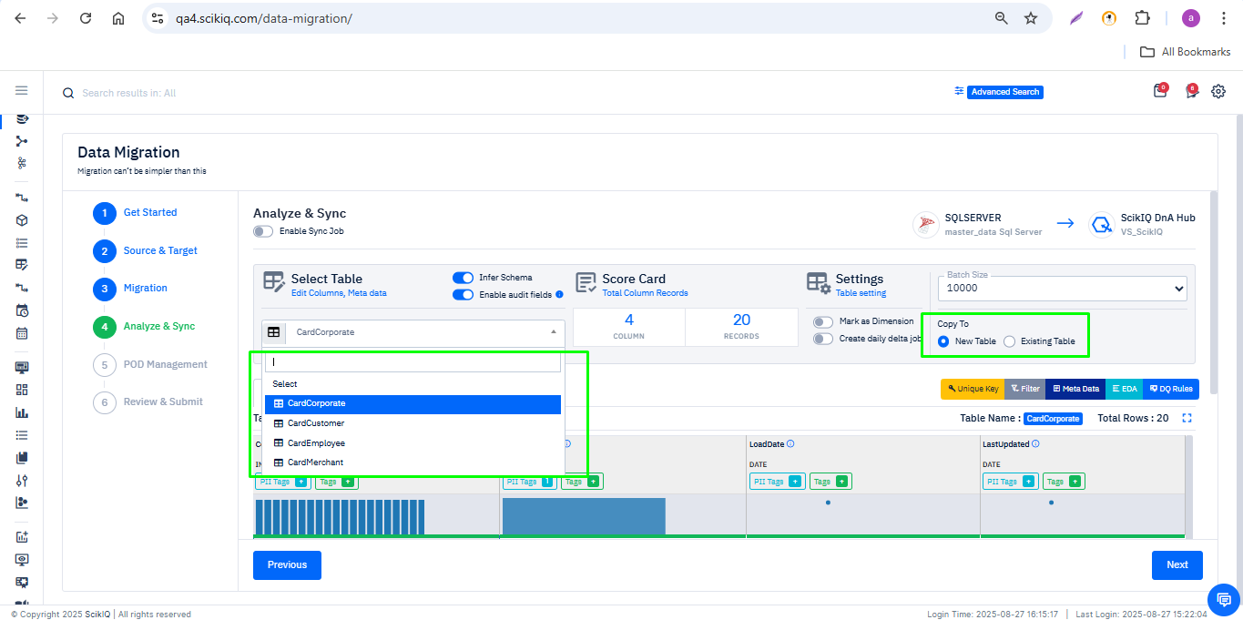

3.6 POD Management
- All selected tables will be displayed on the default POD.
- Additional PODs can be created, and tables can be dragged & dropped into them.
- Click Next.
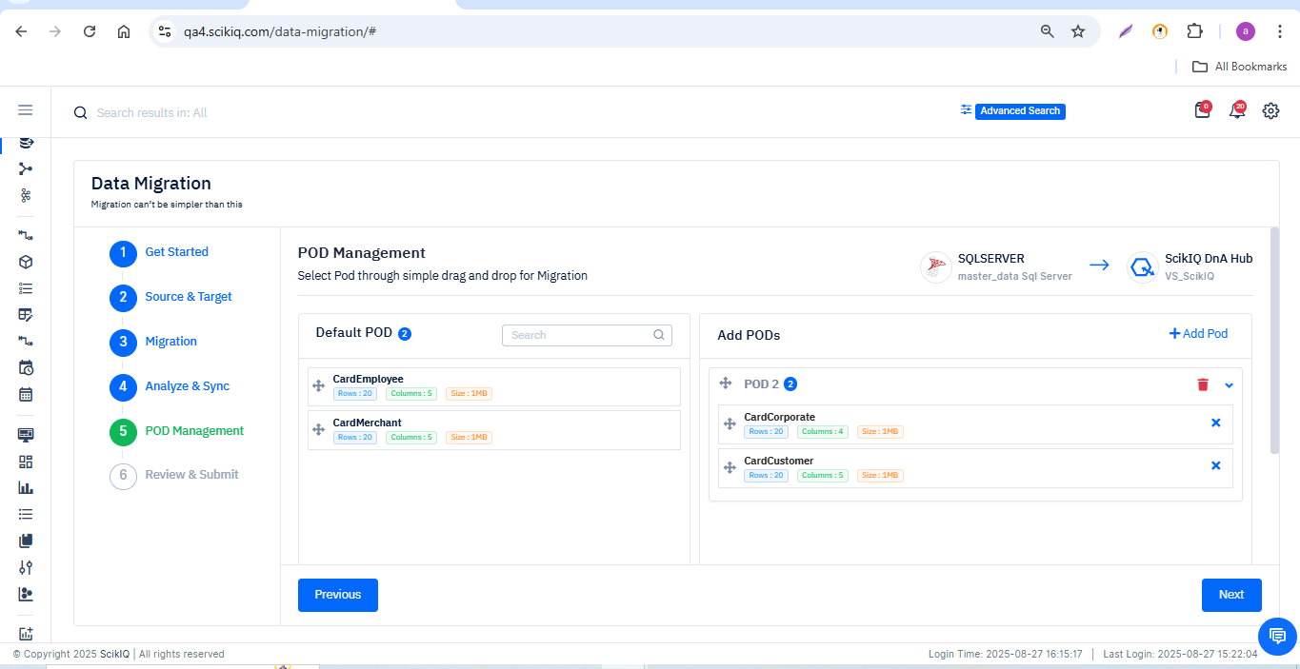

3.7 Review & Submit
- Provide the Task Name and Description.
- Review the task summary.
- Click Finish to submit.
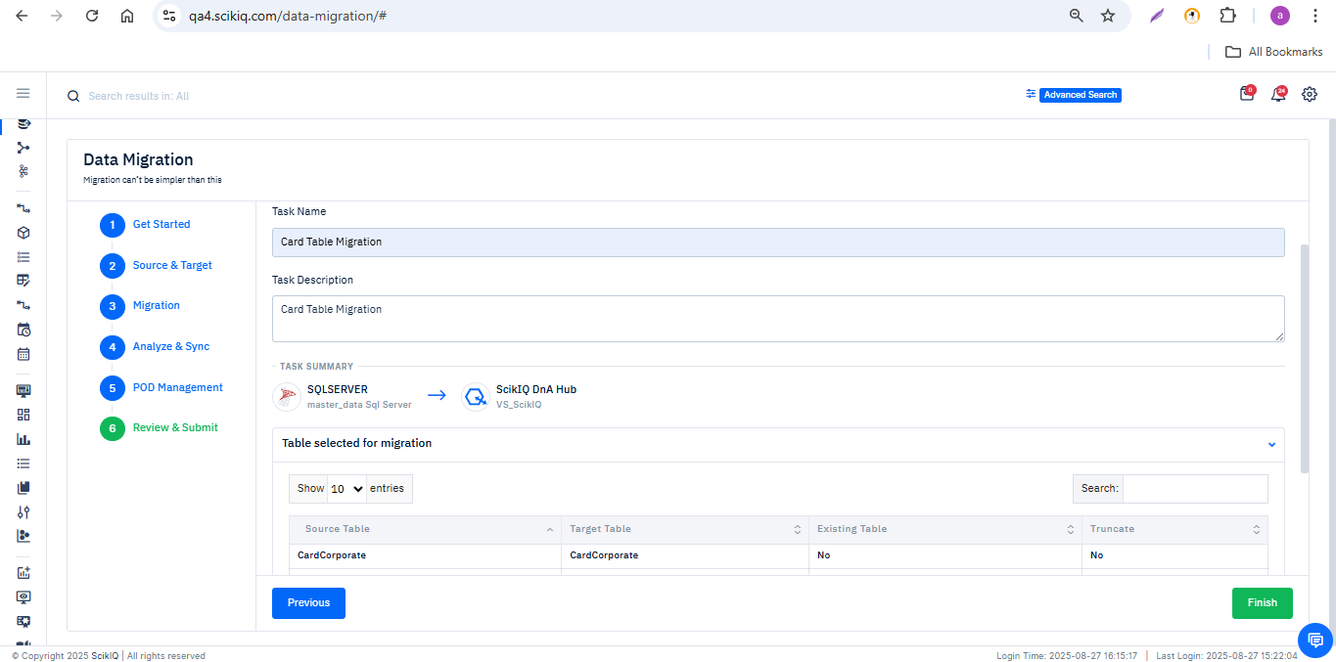
- After clicking Finish, a confirmation message will appear: 'Data migration job is created successfully!' with a request number.
- Click OK to proceed.
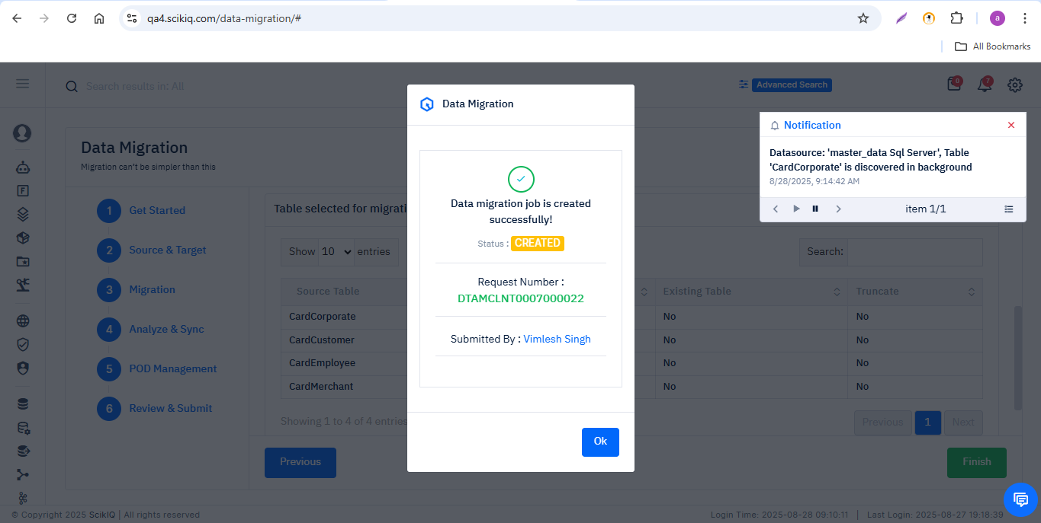

3.8 Data Migration Request
- The platform will redirect to the Migration Request screen where the new migration will be listed.
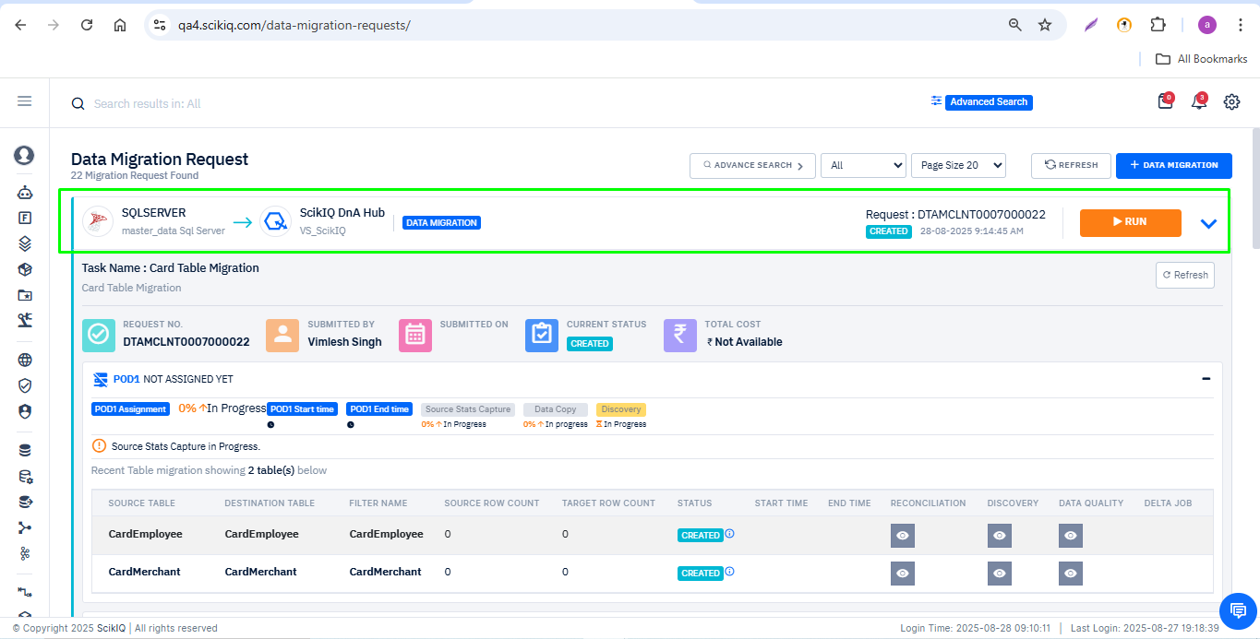

3.9 Migration Schedule
- Click RUN on the migration job.
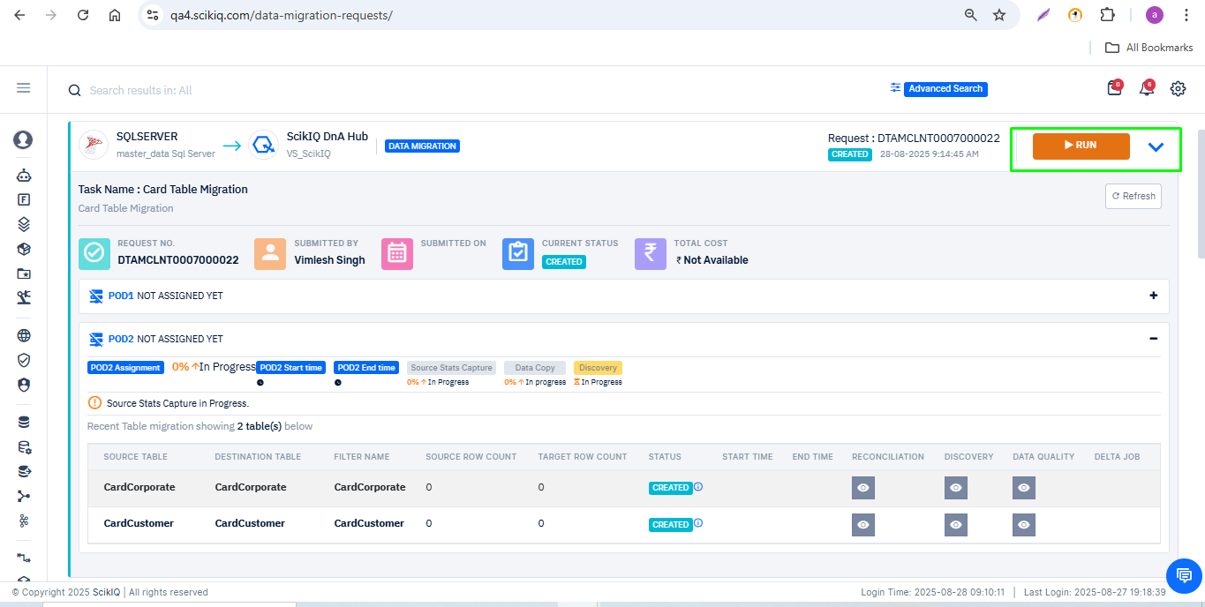
- In the scheduler window, choose one of the following options:
  - Run Now – job starts immediately.
  - Run Later – specify Start Date and Start Time.
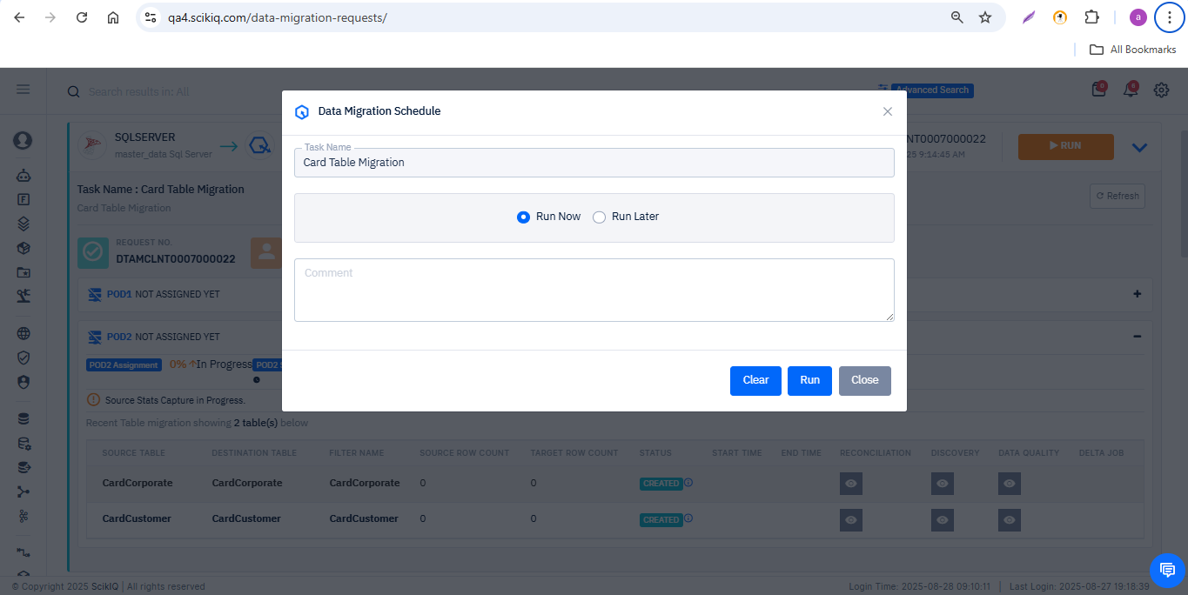
- Select the “Run Later” option, then specify the start date and time.
  - Example: The job is scheduled for 28th August at 9:25AM.
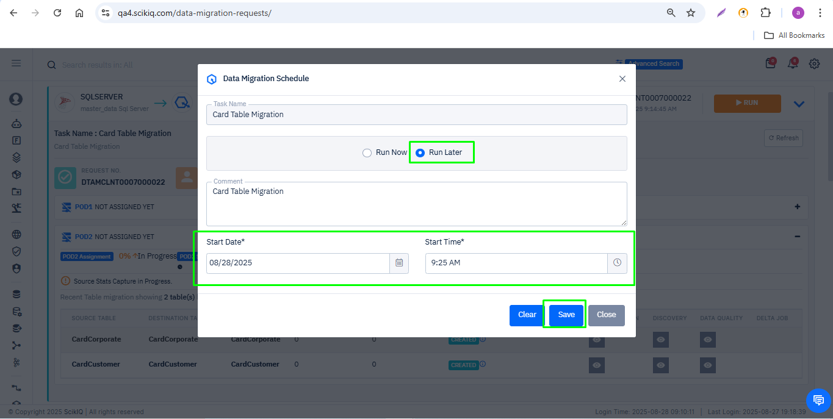
- Click Save. A successful message will appear: 'Migration Scheduled', and job status will change from Created to Submitted.
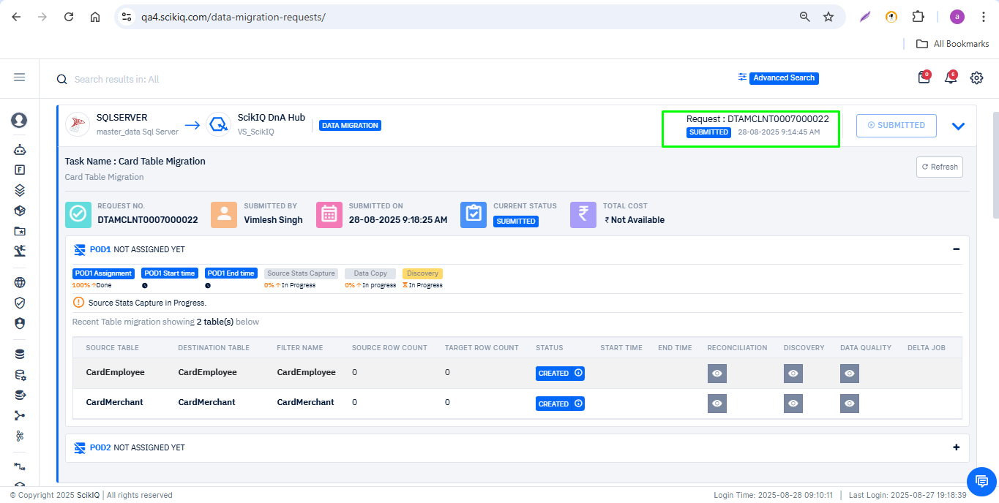

3.10 Before Execution
- Start Time and End Time fields will remain blank.
- Job status will show as Created.
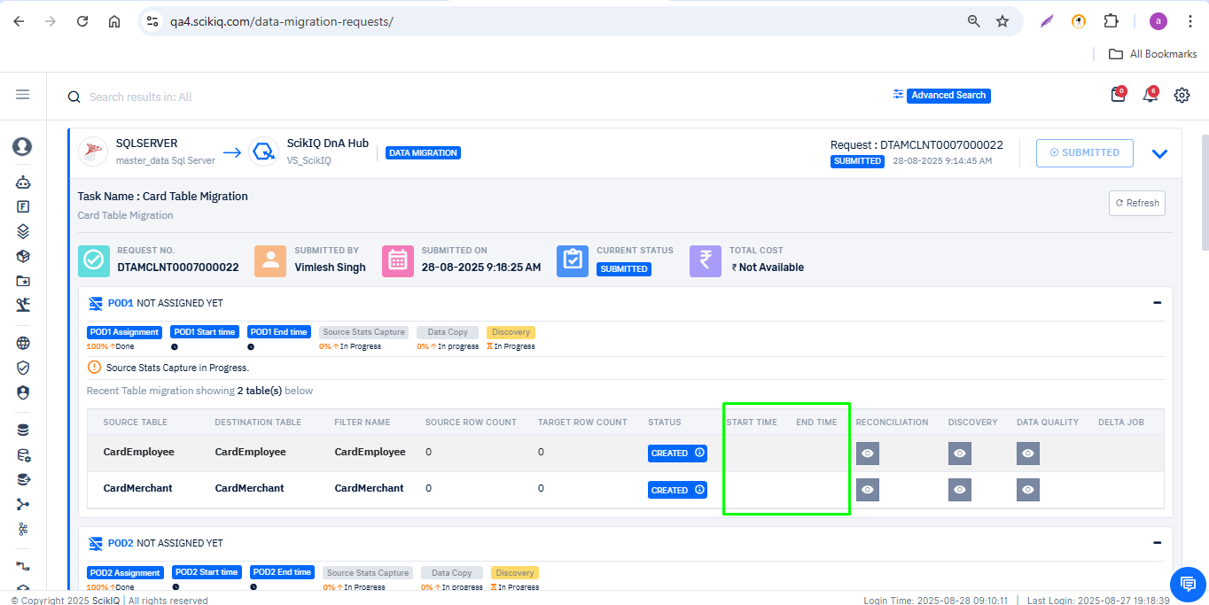

3.11 During Execution
- At Scheduled Time- The migration job status changes to In Progress.
- For each selected table, the status will show as Data Copied once the data transfer is complete.
- Start and End times are updated for every migrated table.
- Source row count and Target row count are displayed for comparison.
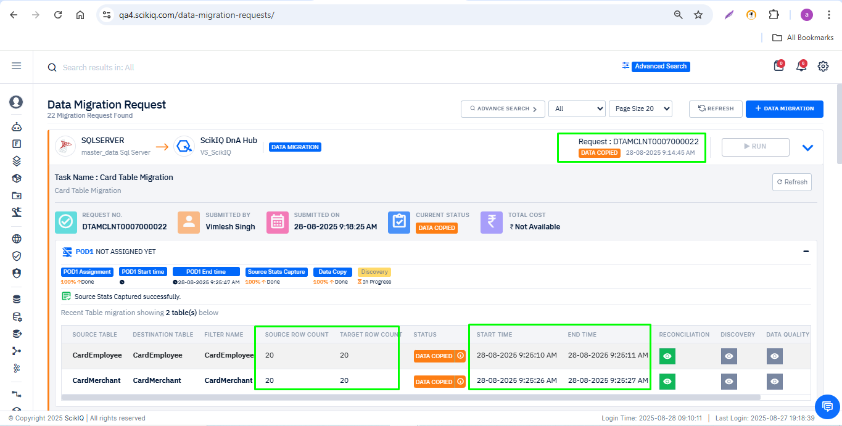

3.12 After Migration Completion
- Once validation/discovery is complete, the overall migration job status changes from Data Copied to Finished.
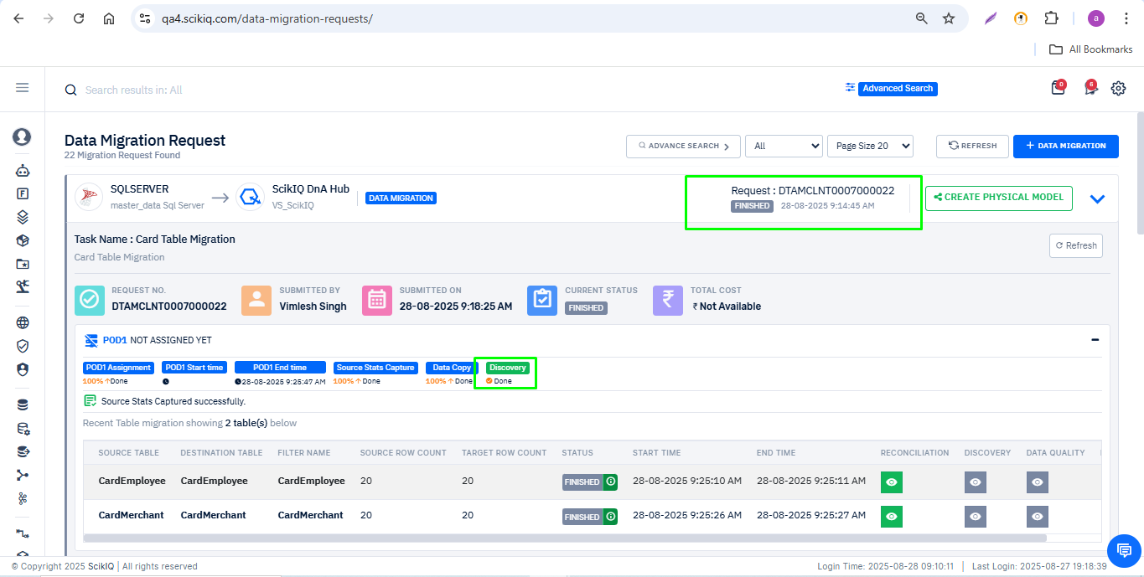
- The target database will contain the migrated tables, and users can verify the successful transfer.



